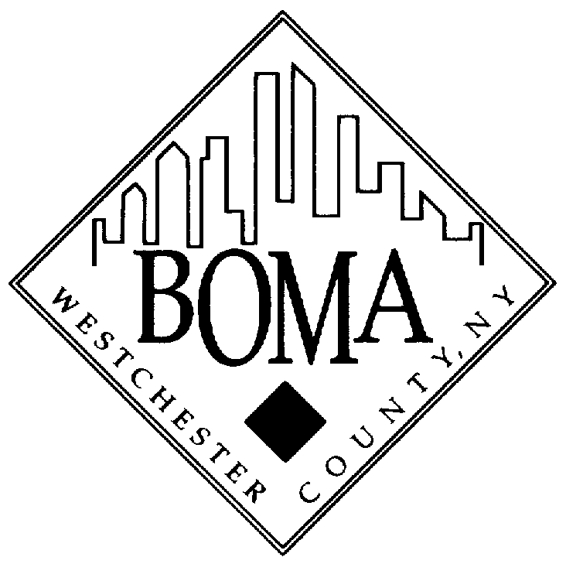

MEMBERSHIP DUES INFORMATION

PRINCIPAL (REGULAR) - $870 per annum
A person or entity owning, managing or otherwise actively involved with real property. A principal member will be a member of BOMA International and receive regular correspondence from both BOMA Westchester and BOMA International.

ADDITIONAL PRINCIPAL - $414 per annum
The second and subsequent members from a member company. An additional principal member has full membership privileges in BOMA Westchester and BOMA International.

CORPORATE PRINCIPAL MEMBER - $1,517 per annum
This category is open to real estate owners and/or managers who wish to have multiple company representatives as BOMA members. Each corporate member company is entitled to three company representatives who will all be full voting members of BOMA Westchester and BOMA International. A dues rate of $382.00 will be invoiced for corporate representatives over the initial 3.

PROFESSIONAL - $870 per annum
A person or entity actively engaged in performing professional services for the real estate industry, including attorneys, architects, engineers, etc. A professional member will be a member of BOMA International and receive regular correspondence from both BOMA Westchester and BOMA International. Professional members are eligible to join the Allied Committee.

ALLIED - $1,141 per annum
A person or entity who provides products or services to the real estate industry. Although allied members may own buildings, if the primary reasons for joining BOMA is to represent a company providing products and services rather than one owning or managing real estate, this is the proper category. An allied member will be a member of BOMA International and receive regular correspondence from both BOMA Westchester and BOMA International. An allied company may also have "Additional" members with a dues rate of $406.00 per additional member. Allied Additional members will not be considered members of BOMA International.

THE MEMBERSHIP YEAR
The membership year runs from January to December. Members who join after June 1 pay 60% of the annual fee.

ACCEPTANCE OF MEMBERSHIP APPLICATIONS
All membership applications submitted should be accompanied by a check payable to BOMA Westchester. Applications will be reviewed by the Board of Directors before membership is granted. Applicants will be notified upon acceptance.

